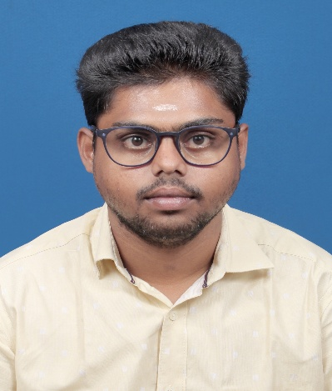

CONTACT

9597303352,7010282640

rockyanantha7@gmail.com

Triuchirapalli, India

EDUCATION

**Master of Computer Science**

St Joseph’s College (Autonomous) Trichy-2.

**B.C.A Computer Application**

St Joseph’s College (Autonomous) Trichy-2.

**Higher Secondary**

Vidyaa Vikas Matriculation Higher Secondary School, Gandrvakottai, Pudukkottai,Tn

**Secondary**

Campion Anglo Higher Secondary School, Triuchirapalli

SKILL

* **Programming:** PHP, SQL, Python, ASP.NETWeb
* **Web Design & Tools:** HTML, CSS, Photoshop
* **Database Management:** MySQL, SQL Server
* **Other:** Data Entry, Problem-Solving, Team Collaboration

S.ANANTHAPATHMANAPAN

Junior Programmer

# ABOUT ME

To obtain a position in a leading organization where my abilities and knowledge can be effectively utilized, developed, and encouraged, enabling me to contribute to the organization’s success and become a valuable long-term asset."

# **WORK EXPERIENCE**

February 2025 - present

St.Joseph’s College(Autonomous), Tiruchirapalli.

## Junior Programmer

October 2022 – February2025

DSM Soft (P)Ltd.Trichy.

November 2021- August 2022

National College (Autonomous) Trichy.

## At Controller of Examinations Office

## Data Entry Operator

HOBBIES & INTEREST

I am interested in photography and enjoy playing games like cricket and football. I am also passionate about web design, as well as social activities and social media engagement.

ACHIEVEMENTS

Attended the National Seminar on Innovation in Computer Science and Application (NSICSA’20) held in Perambalur on 26th February 2020.

STRENGTHS

* **Excellent in general knowledge and computational skills.**
* **Strong motivational and leadership skills.**
* **Ability to work effectively under pressure.**
* **Ability to work independently as well as in a team.**

REFERENCE

**Dr. V. Maria Antoniatte Martin, M.Sc., M.Phil., Ph.D.  
Assistant Professor, Department of IT  
St. Joseph’s College, Trichy-2  
Contact: +91 909557958**

**DECLARATION**

**"I hereby declare that the above-mentioned details are true and correct to the best of my knowledge and belief."**

PLACE: Trichy Yours faithfully

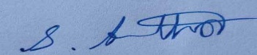 DATE: S ANANTHAPATHMANAPAN